(Approx. 382 words)

Open Source Lab
Linux Mint 19.2
Author: Cal Esneault, Former President and leader of many Open Source Workshops & SIGs, Cajun Clickers Computer Club
September issue, Cajun Clickers Computer News
www.clickers.org
tsa70785 (at) gmail.com

Linux Mint is a Linux distribution based on Ubuntu. A long-term support version, Linux Mint 19, was released in June of 2018. An updated version, Mint 19.2, was released in August 2019. This version is known as a “point” release, and only software developed by Linux Mint has new features different than Mint 19 (the majority of programs remain tied to the latest Ubuntu LTS repository). A few of the applications maintained by the Linux Mint team are listed below.
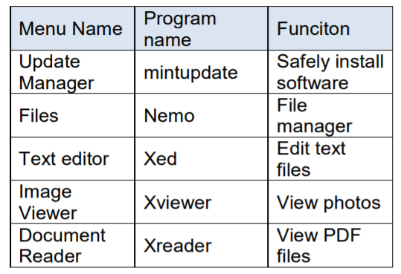
Users of Mint 19.1 can do a guided “in-place” upgrade to Mint 19.2 using the Mint Update Manager tools. Just be sure to first back-up the operational parts of your system using “Timeshift” and run the entire upgrade without interruption. None of your personal files will be affected. After reboot, you will be running the newest version.

Linux Mint developers have always tried to minimize user problems after updates. First, they classified updates into categories with respect to breadth of system impact. With increased frequency of Linux kernels, they made recovery from system-wide problems easier. As more installed but inactive kernels began to accumulate and increase system backup overhead, they allowed removal of older kernels one at a time using the Update Manager. With mint 19.2, they added a feature to remove multiple kernels simultaneously.

The Update Manager dialog screens changed significantly in the 19.2 version. The main menu reduced the number tabbed controls from five to three (see screen below).
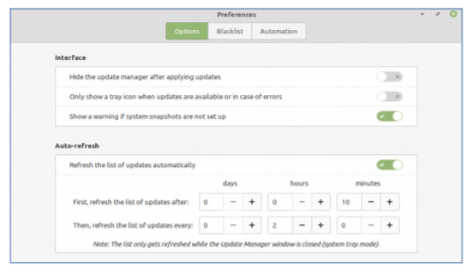

Besides simplification, the “levels” tab was eliminated. This seems to de-emphasize the previous strategy of impact categorization in favor of installing all updates with ability to roll-back the OS in case of failures.

If you are currently running Mint 19.1, this is an easy upgrade with very minimal risk. In that case, it is recommended to upgrade. If you are running Mint 18.x or another distro, however, this install would require a full rebuild and necessitate a lot of effort to maintain your existing information. In that case, don’t install it unless you have studied the situation and have decided this is best for your long-term needs.

